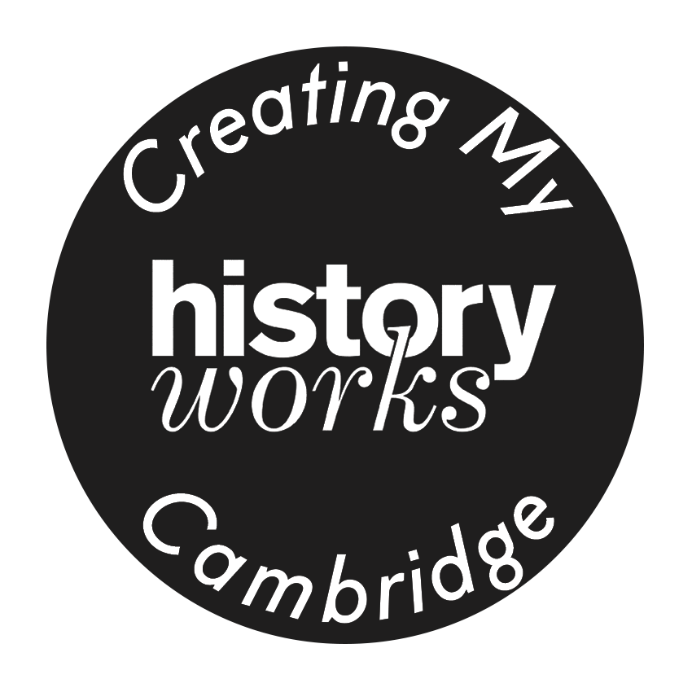

Photo / Video/ Audio consent form

Dear participant/ parents/guardians/carers,

HistoryWorks has been producing Public History projects for over 20 years and our Arts Project called ‘CreatingMyCambridge’ for 7 years. HistoryWorks also runs Holocaust Memorial Day events and an HMD Education programme on behalf of the City of Cambridge Council. Plus organizing Refugee Week events & fundraisers.

We would be grateful if you could fill-in this form to give HistoryWorks permission to use the video or artworks you are submitting for the event for Holocaust Memorial Day online. Also, to cover subsequent ‘CreatingMyCambridge’ activities for live events & rehearsals to take photos or record video/audio of you, your child or family.
We will use these photos/videos/audio recordings in online or electronic or printed publications, which are for sharing publicly. These materials include, but are not limited to: online events, films, newsletters, web stories, media coverage, posters, leaflets, e-newsletters, blogs, podcasts, web pages, social media posts, presentations, speeches, research, newspaper features and case studies. HistoryWorks will take utmost care that these photos/videos are not used for other purposes.

Please contact HistoryWorks via historyworkstv@gmail.com should you like to retract your permission at any time.

***********************************************************************
I give permission for the person/ child named for their recorded video of a story, song or poem or dance or drama for HistoryWorks to use for online events for marking Holocaust Memorial Day, International Refugee Week, or a CreatingMyCambridge project: http://www.creatingmycambridge.com/

I grant HistoryWorks rights to use these images/videos resulting from the audio or photography/video filming (and any reproductions or adaptations of the images/videos) for fundraising, publicity or other purposes. These include, but are not limited to: newsletters, web stories, media coverage, posters, leaflets, e-newsletters, blogs, web pages, social media posts, presentations, speeches, research, newspaper features and case studies. This will help achieve the inspiring aims of Historyworks to promote participation in community history and public art projects.

I understand that I can withdraw my consent at any time by contacting HistoryWorks directly. If I withdraw my consent, HistoryWorks will no longer use any information I have provided previously, and will delete any relevant data from their systems. However, I understand that any printed, published materials that already include my information cannot be recalled.

I understand that I have the right to access my personal data (photos, videos, audio recordings) on request, and I have the right to request removal of my data from websites, social media and future versions of printed materials.

This consent applies for minimum of 5 years from the date below so as the films and photos produced can be online for 5 years afterwards. I understand this information will be logged efficiently and all data will be deleted at the appropriate time.

I understand that I and/or the child, family member or school do not own the copyright or have any rights of ownership -- or other claims -- over the photographs or videos or audio or artworks – but that the organization is committed to public art so that HistoryWorks aims to share assets with partners so that performers, schools, museums, heritage sites, galleries, artists, musicians can share for their own newsletters and websites and social media via all the published film and audio assets having embedded a creative commons agreement.

PLEASE WRITE CLEARLY IN BLOCK CAPITALS & SUBMIT TO OUR HISTORYWORKS DROPBOX SET UP FOR CONSENT FORMS HERE

- Name of Participant/ Child / family member
- Name of Parent/Guardian for participant
- Signature for Participant/ Parent / Guardian
- IYOU CAN INITIAL IF NO ACCESS TO SCANNER
- Contact Adult’s Email / Mobile (optional)
- Date

